Bb Annotate Quick Start Guide for Instructors (Original Course View)

From either the Needs Grading page or the Grade Center within the course, access the student’s submission to provide inline grading feedback using Bb Annotate.
Supported File Types
On the Grade Assignment page, supported file types open automatically in the browser.
You can view and annotate these document types in the browser:
- Microsoft® Word (DOC, DOCX)
- Microsoft® PowerPoint®(PPT, PPTX)
- Microsoft® Excel®(XLS, XLSM, XLSX)
- OpenOffice® Documents (ODS, ODT, ODP)
- Digital Images (JPEG, JPG, PNG, TIF, TIFF, BMP, TGA)
- Medical Images (DICOM, DICM, DCM)
- PDF
- PSD
- RTF
- TXT
- WPD
Original formatting and embedded images are preserved. If a student has uploaded an unsupported file, you're prompted to download it. Additionally, assignment submissions created through the editor aren’t compatible with inline grading.

Supported Browsers
Bb Annotate is supported on current versions of Firefox, Chrome, and Safari.

Bb Annotate Menu
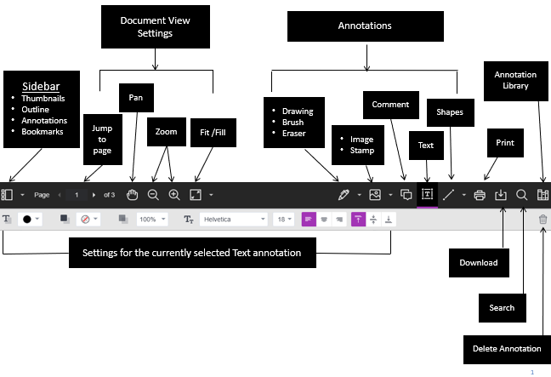

There is a wide array of features to select from in the menu.

As part of the responsive design, the menu will appear differently based on the screen size. On medium and small screens, the Document View settings will change to display the page number being viewed, and annotation tools will be visible under the View Annotation Tools icon. On small screens, the Content Library will be hidden.

Sidebar View
The left Sidebar view allows you to see a thumbnail view of the submission, an outline, list of all annotations and bookmarks. You can show or hide the sidebar as well as resize it.

Document View Settings
From the view settings, it is easy to jump to a specific page, zoom in and out of the submission or adjust the view to fit the page, fit the width or select the best fit.

Annotations
- Drawing, Brush and Eraser – The drawing and brush tools allow you to freehand draw on the document using various colors, thickness, and opacity. You’ll have the option to either erase pieces of the freehand drawing or delete fully using the trash icon.
- Image or Stamp – An image or stamp can be added to the document. There are a set of pre-loaded stamps or create your own customized stamp.
- Comment – Comments can be added to the document to provide feedback and will appear to the right of the submission. You and other graders can add additional replies to a comment.
- Text – You can add text directly on the page. There are additional options to move, edit and change the appearance of the text, including font, size, alignment and color.
- Shapes – There are 6 options for adding shapes: Line, Arrow, Rectangle, Ellipse, Polygon and Polyline. Each option has its own customization settings to change the color, width, opacity, and more.

Print or Download
You can either Print or Download the document with annotations. When downloading, it is recommended to view annotated PDF’s in a native PDF viewer such as Adobe Acrobat.

Search
You can quickly search through the document to find specific text.

Content Library (only available in SaaS environments)
The content library allows you to keep a bank of re-usable comments. You can easily add, edit, delete, or search through comments in the library. A comment can be added directly to the page as well through the context menu.

Highlighting
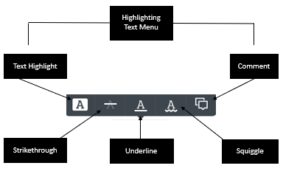

When directly highlighting text on a submission, an additional menu will open to allow you to highlight, strikethrough, underline, or comment.

Student View
After you have provided a grade, students can access the annotated files but won’t be able to add annotations in their submissions.

