Zoom Web Conferencing-Assigning Scheduling Privileges

Hello Interviewers,

Thank you again for participating in our Interview Day on #DATE#. We will have #NUMBER# virtual rooms for our interviews in the morning and the afternoon sessions. You will receive your individual itinerary later today. For each room, there will be one Zoom meeting scheduled. We will have a Zoom meeting on #DATE# at #TIME# to review the details of these Zoom meetings.

In order to schedule and manage these meetings on our interview day, I am requesting that you assign me Scheduling Privileges in your Zoom account.

Please complete the following steps to Assign me SCHEDULING PRIVILEGES.
- Log into your Zoom Account #LOG IN LINK#
- Go to Settings, located on left side of the page
- Scroll to the bottom of the page and Under the “Other” section, go to Schedule Privilege
- After Assign Scheduling Privileges, Click on the plus sign, “+”, and you will open this pop up box
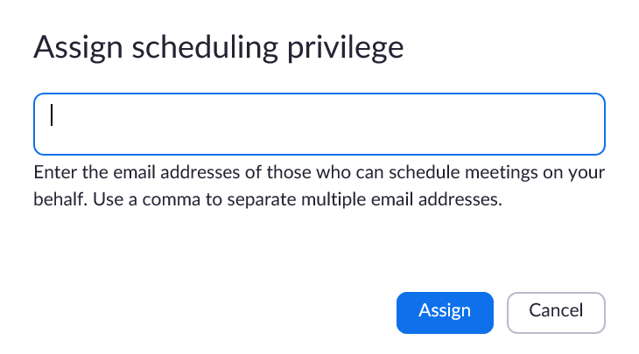
- Type in #COORDINATOR’S JHED@JH.EDU#, then click on Assign. Please note that the extension is @jh.edu, not @jhmi.edu or @jhu.edu
- You should then see #COORDINATOR’S JHED@JH.EDU# listed under the plus sign
- Congrats, you are done! I will then schedule the Zoom meetings for our interview day.
And please note that in order to schedule these Zoom meetings, you cannot be hosting any other Zoom meetings at the same time. Please check your calendars to ensure that you are not hosting any Zoom meetings on #INTERVIEW DATE#.

Please expect to receive a meeting invite for a Trial Run of Zoom meetings on #DATE# at #TIME#. Meeting invite to follow. We will walk you through the steps to run your Zoom interviews.

